SQL Server 2012 Architecture

Components of the SQL Server Engine
Figure 1-1 shows the general architecture of SQL Server, which has four major components (three of whose subcomponents are listed): protocols, the relational engine (also called the Query Processor), the storage engine, and the SQLOS. Every batch submitted to SQL Server for execution, from any client application, must interact with these four components.
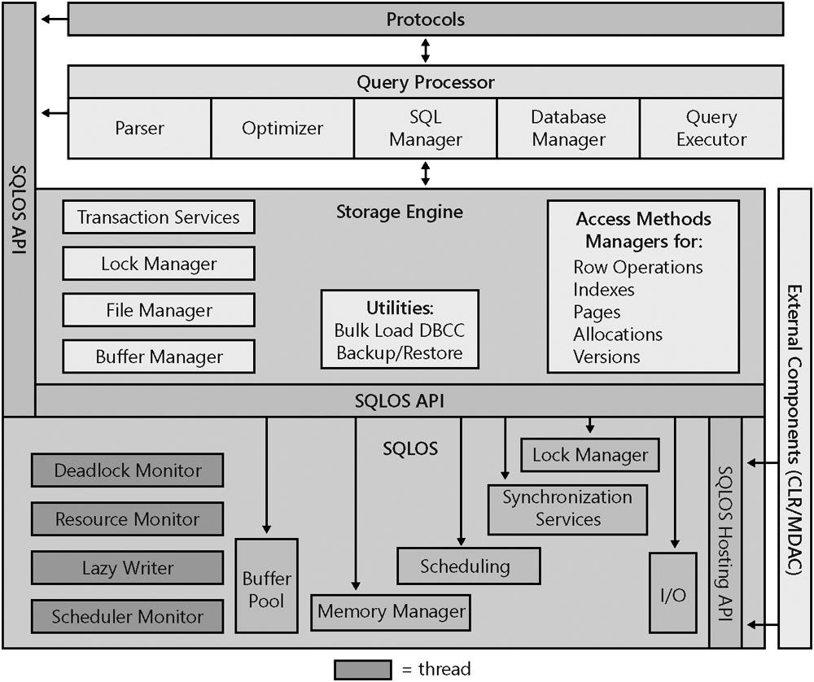
Figure 1-1: The major components of the SQL Server database engine
The protocol layer receives the request and translates it into a form that the relational engine can work with, and it also takes the final results of any queries, status messages, or error messages and translates them into a form the client can understand before sending them back to the client. The relational engine layer accepts SQL batches and determines what to do with them. For Transact-SQL queries and programming constructs, it parses, compiles, and optimizes the request and oversees the process of executing the batch. As the batch is executed, if data is needed, a request for that data is passed to the storage engine. The storage engine manages all data access, both through transaction-based commands and bulk operations such as backup, bulk insert, and certain DBCC (Database Consistency Checker) commands. The SQLOS layer handles activities that are normally considered to be operating system responsibilities, such as thread management (scheduling), synchronization primitives, deadlock detection, and memory management, including the buffer pool.

Protocols
When an application communicates with the SQL Server Database Engine, the application programming interfaces (APIs) exposed by the protocol layer formats the communication using a Microsoft-defined format called a tabular data stream (TDS) packet. There are Net-Libraries on both the server and client computers that encapsulate the TDS packet inside a standard communication protocol, such as TCP/IP or Named Pipes. On the server side of the communication, the Net-Libraries are part of the Database Engine, and that protocol layer is illustrated in Figure 1-1. On the client side, the Net-Libraries are part of the SQL Native Client. The configuration of the client and the instance of SQL Server determine which protocol is used.
SQL Server can be configured to support multiple protocols simultaneously, coming from different clients. Each client connects to SQL Server with a single protocol. If the client program does not know which protocols SQL Server is listening on, you can configure the client to attempt multiple protocols sequentially. The following protocols are available:
- Shared Memory The simplest protocol to use, with no configurable settings. Clients using the Shared Memory protocol can connect only to a SQL Server instance running on the same computer, so this protocol is not useful for most database activity. Use this protocol for troubleshooting when you suspect that the other protocols are configured incorrectly. Clients using MDAC 2.8 or earlier cannot use the Shared Memory protocol. If such a connection is attempted, the client is switched to the Named Pipes protocol.
- Named Pipes A protocol developed for local area networks (LANs). A portion of memory is used by one process to pass information to another process, so that the output of one is the input of the other. The second process can be local (on the same computer as the first) or remote (on a networked computer).
- TCP/IP The most widely used protocol over the Internet. TCP/IP can communicate across interconnected networks of computers with diverse hardware architectures and operating systems. It includes standards for routing network traffic and offers advanced security features. Enabling SQL Server to use TCP/IP requires the most configuration effort, but most networked computers are already properly configured.

Tabular Data Stream Endpoints
From SQL Server 2005 onwards a new concept for defining SQL Server connections: the connection is represented on the server end by a TDS endpoint. During setup, SQL Server creates an endpoint for each of the four Net-Library protocols supported by SQL Server, and if the protocol is enabled, all users have access to it. For disabled protocols, the endpoint still exists but cannot be used. An additional endpoint is created for the dedicated administrator connection (DAC), which can be used only by members of the sysadmin fixed server role.

The Relational Engine
As mentioned earlier, the relational engine is also called the query processor. It includes the components of SQL Server that determine exactly what your query needs to do and the best way to do it. By far the most complex component of the query processor, and maybe even of the entire SQL Server product, is the query optimizer, which determines the best execution plan for the queries in the batch.
The relational engine also manages the execution of queries as it requests data from the storage engine and processes the results returned. Communication between the relational engine and the storage engine is generally in terms of OLE DB row sets. (Row set is the OLE DB term for a result set.) The storage engine comprises the components needed to actually access and modify data on disk.

The Command Parser
The command parser handles Transact-SQL language events sent to SQL Server. It checks for proper syntax and translates Transact-SQL commands into an internal format that can be operated on. This internal format is known as a query tree. If the parser doesn’t recognize the syntax, a syntax error is immediately raised that identifies where the error occurred. However, non-syntax error messages cannot be explicit about the exact source line that caused the error. Because only the command parser can access the source of the statement, the statement is no longer available in source format when the command is actually executed.

The Query Optimizer
The query optimizer takes the query tree from the command parser and prepares it for execution. Statements that can’t be optimized, such as flow-of-control and DDL commands, are compiled into an internal form. The statements that are optimizable are marked as such and then passed to the optimizer. The optimizer is mainly concerned with the DML statement SELECT, INSERT, UPDATE, and DELETE, which can be processed in more than one way, and it is the optimizer’s job to determine which of the many possible ways is the best. It compiles an entire command batch, optimizes queries that are optimizable, and checks security. The query optimization and compilation result in an execution plan.
The first step in producing such a plan is to normalize each query, which potentially breaks down a single query into multiple, fine-grained queries. After the optimizer normalizes a query, it optimizes it, which means it determines a plan for executing that query. Query optimization is cost based; the optimizer chooses the plan that it determines would cost the least based on internal metrics that include estimated memory requirements, CPU utilization, and number of required I/Os. The optimizer considers the type of statement requested, checks the amount of data in the various tables affected, looks at the indexes available for each table, and then looks at a sampling of the data values kept for each index or column referenced in the query. The sampling of the data values is called distribution statistics. Based on the available information, the optimizer considers the various access methods and processing strategies it could use to resolve a query and chooses the most cost-effective plan.

The Database Manager
The database manager handles access to the metadata needed for query compilation and optimization, making it clear that none of these separate modules can be run completely separately from the others. The metadata is stored as data and is managed by the storage engine, but metadata elements such as the data types of columns and the available indexes on a table must be available during the query compilation and optimization phase, before actual query execution starts.

The Query Executor
The query executor runs the execution plan that the optimizer produced, acting as a dispatcher for all the commands in the execution plan. This module steps through each command of the execution plan until the batch is complete. Most of the commands require interaction with the storage engine to modify or retrieve data and to manage transactions and locking.

The Storage Engine
The SQL Server storage engine has traditionally been considered to include all the components involved with the actual processing of data in your database. SQL Server 2005 separates out some of these components into a module called the SQLOS. In fact, the SQL Server storage engine team at Microsoft actually encompasses three areas: access methods, transaction management, and the SQLOS.

Transaction Services
A core feature of SQL Server is its ability to ensure that transactions are atomic–that is, all or nothing. In addition, transactions must be durable, which means that if a transaction has been committed, it must be recoverable by SQL Server no matter what–even if a total system failure occurs 1 millisecond after the commit was acknowledged. There are actually four properties that transactions must adhere to, called the ACID properties: atomicity, consistency, isolation, and durability.
Locking Operations Locking is a crucial function of a multi-user database system such as SQL Server, even if you are operating primarily in the snapshot isolation level with optimistic concurrency. SQL Server lets you manage multiple users simultaneously and ensures that the transactions observe the properties of the chosen isolation level. Even though readers will not block writers and writers will not block readers in snapshot isolation, writers do acquire locks and can still block other writers, and if two writers try to change the same data concurrently, a conflict will occur that must be resolved. The locking code acquires and releases various types of locks, such as share locks for reading, exclusive locks for writing, intent locks taken at a higher granularity to signal a potential “plan” to perform some operation, and extent locks for space allocation. It manages compatibility between the lock types, resolves deadlocks, and escalates locks if needed. The locking code controls table, page, and row locks as well as system data locks.

